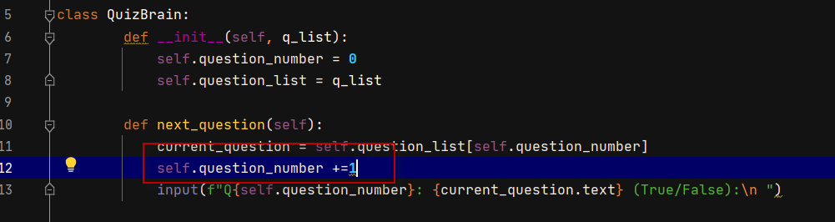Day 17 Inter quiz project

<https://repl.it/@appbrewery/quiz-game-final?embed=1&output=1#main.py>

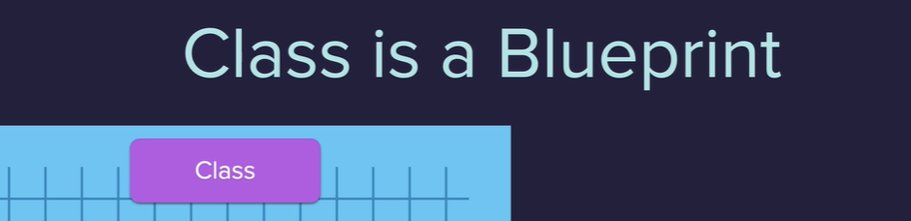

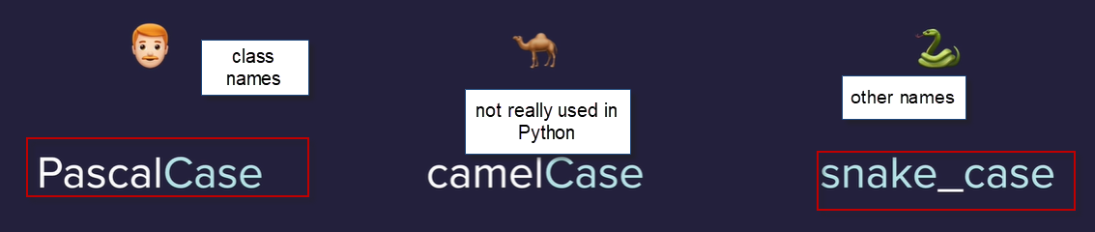

The word pass under an empty class or function will get rid of python indent error

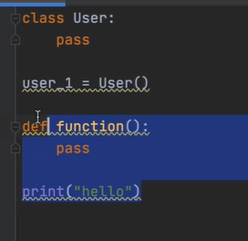

To create an attribute for the class using dot notation – variable associated with an object

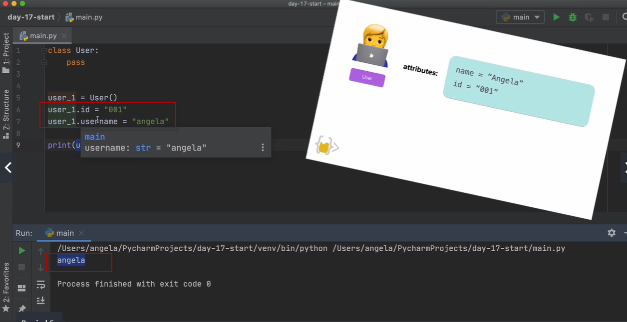

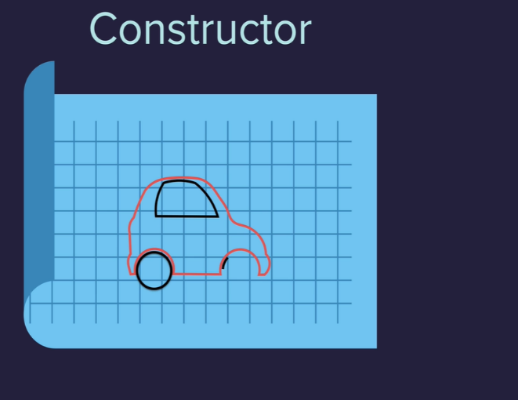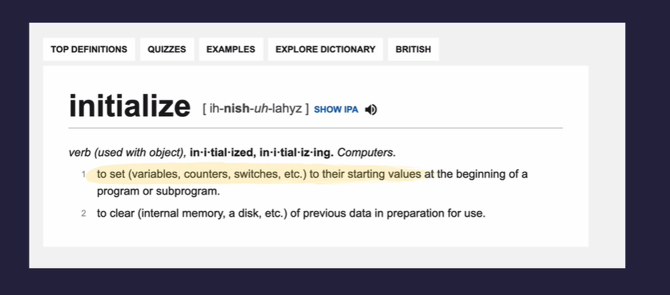

Initialize a constructor using the **Init function** a special method with a special function 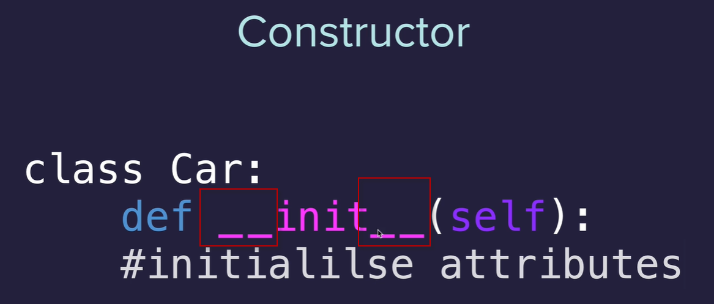

Constructor Create starting vales for our attributes

Initialize the attributes - create there starting values 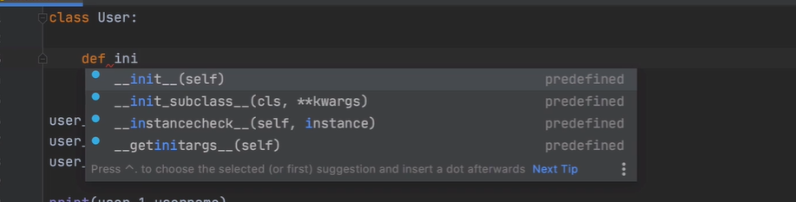

The init function will be called every time you create a new object from this class

Attributes what the object has , Attributes are variables associated with the finial object 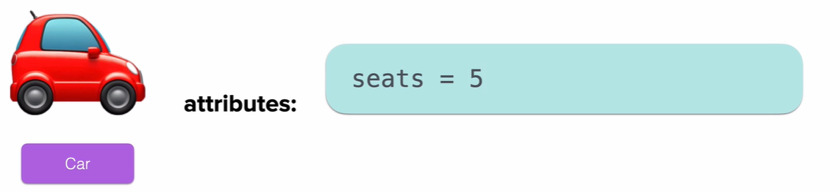

Set in constructor this way

Self is the actual object that bis being initialized, followed by parameters. The parameter gets passed in when an object gets constructed from this class. Once you receive the data, can use it to set the objects attributes.

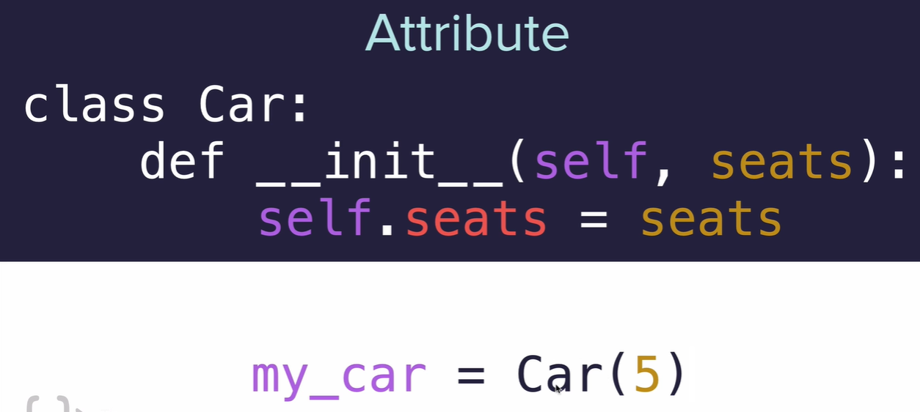

When calling pass in pass data to those parameters which will set the attributes for that object.

Same as



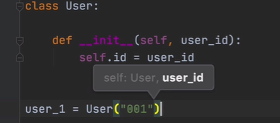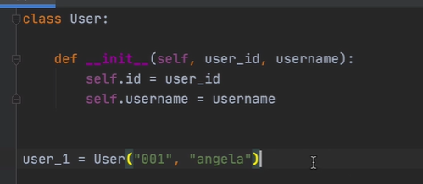

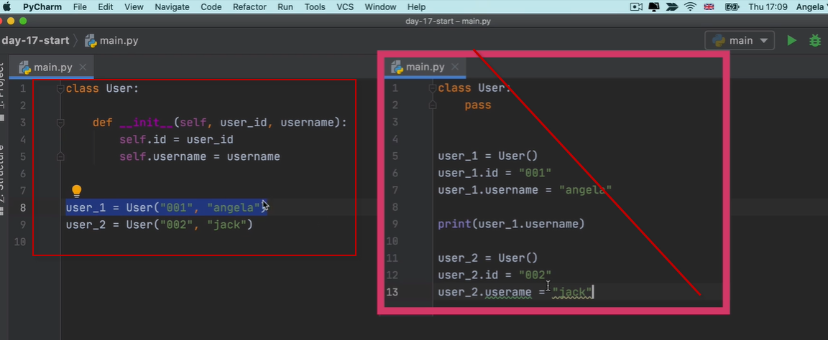

Can also set a default value which doesn’t need to be passed in each time an object is constructed from the class.

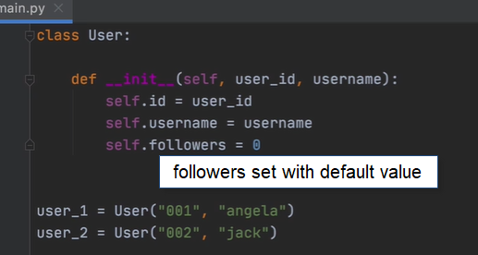

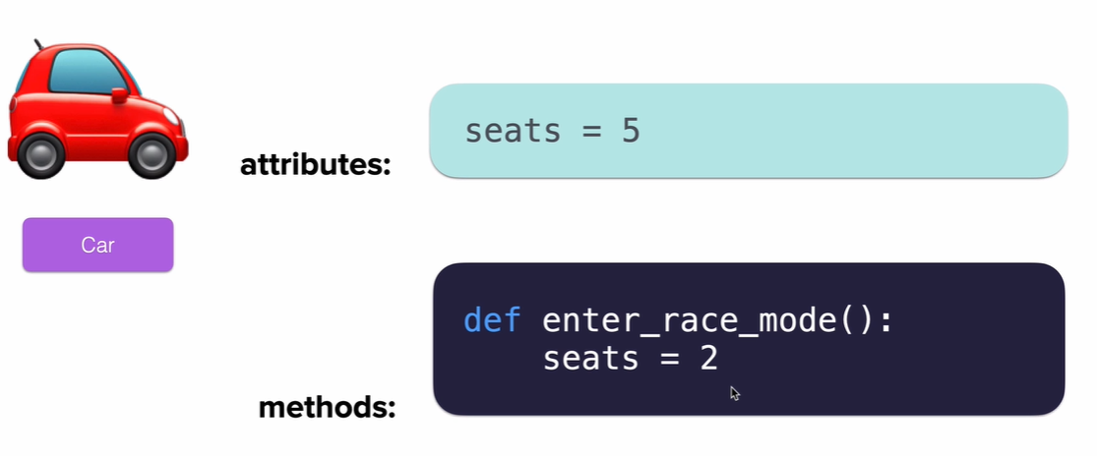

Method what the object does, in the class declare the method using def just like other functions

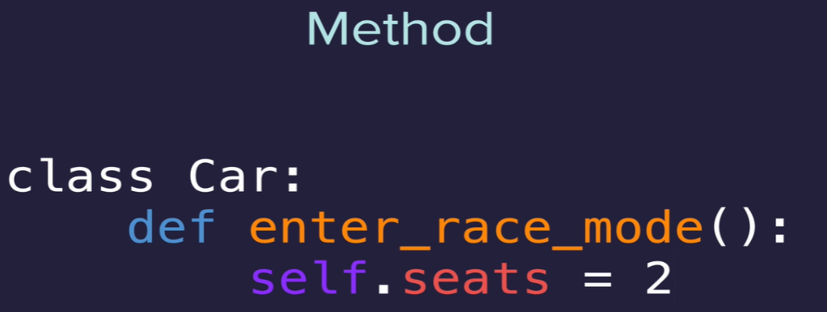

Then to call 

A method, unlike a function, always needs to have a self parameter as the first parameter so it knows the object that called it. Then pass in the user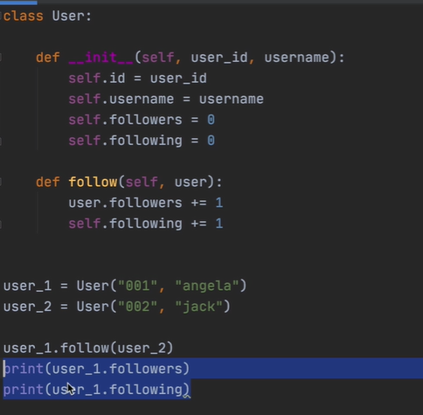

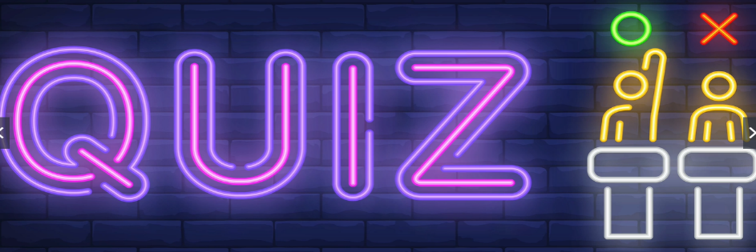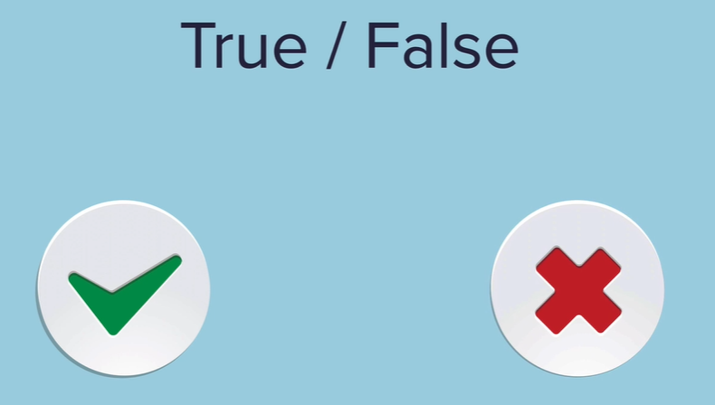

Create model for questions in the quiz – initialize

values

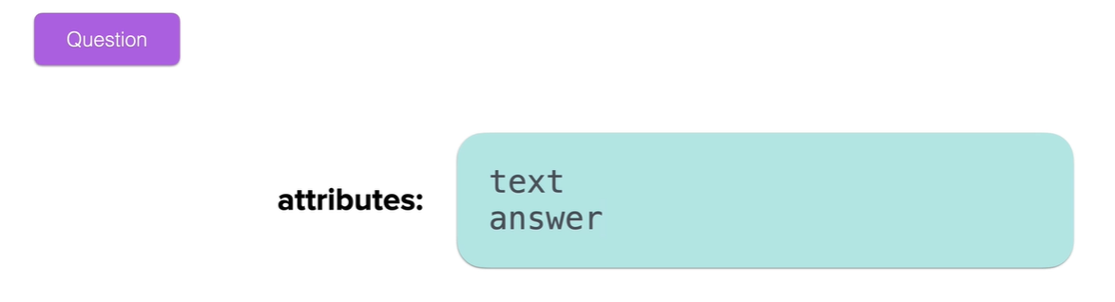

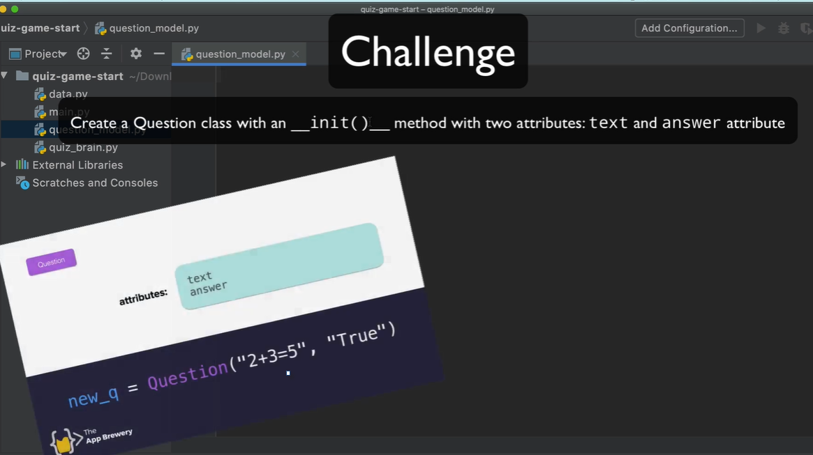

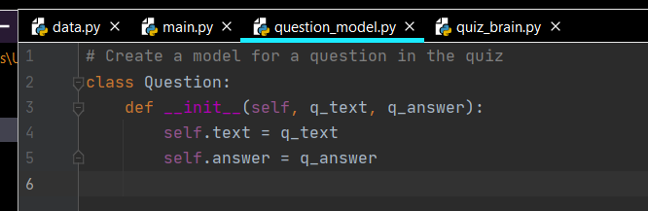

Create question bank Loop through question data end result should be a list of question objects each being initialized with a question and an answer. Data from the dictionaries in the question data.

Need a list of question objectes 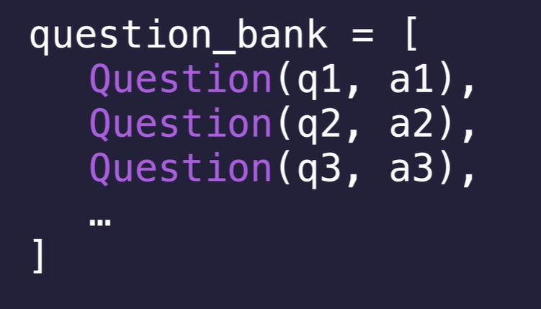

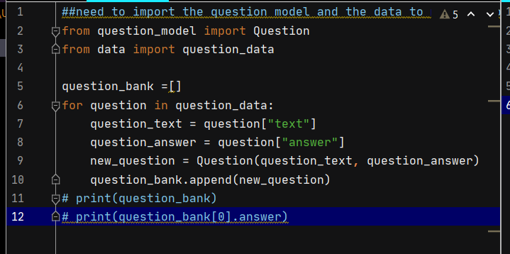

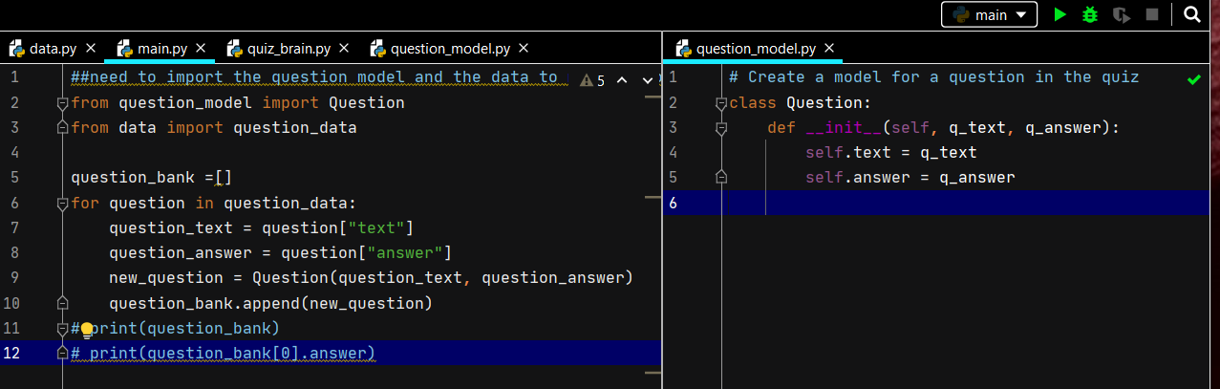

Now bring up the questions and ask user to answer , the logic for this will go into quiz_brain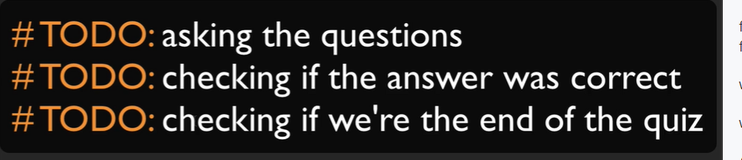

QuizBrain - class is going to have two attributes: a question_list and a question number (which is going to have a default value of zero because all our quizzes will start from the first question. )

And this is going to keep track of which question the user is currently on.

We're going to use that number to go through the list of questions which will be passed over to this QuizBrain object when it gets initialized.

Then have a method which is called next_question() which will pull up the question from that list depending on which current question number we're on.

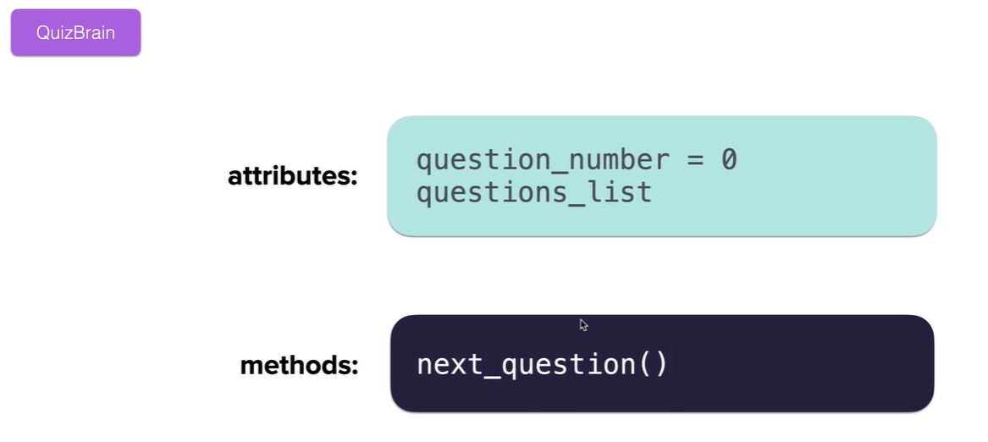

Final version displays the question number , question and true/false

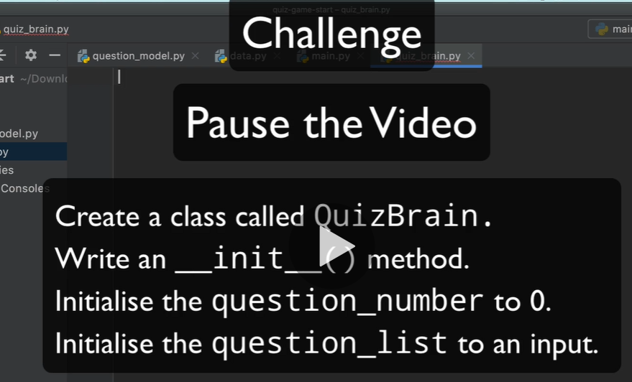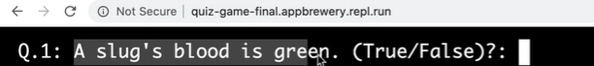

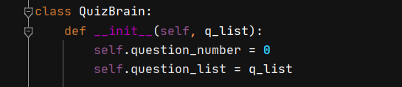

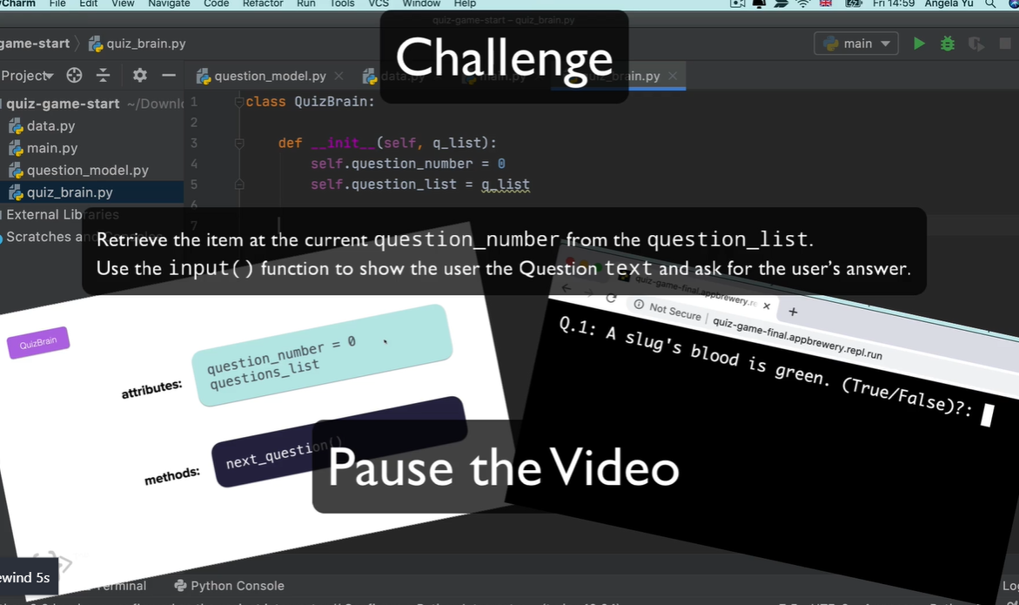

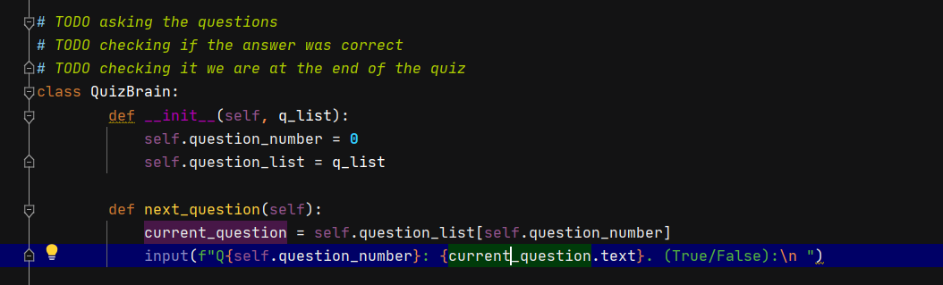

To fix numbering

